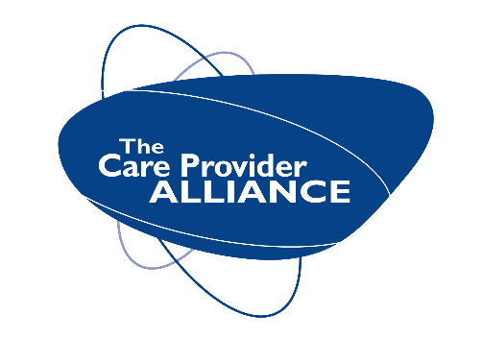

January 2021

Dear social care worker,

Uber discounts on rides for care workers

Uber and the Care Provider Alliance are pleased to announce that care staff in the UK can now benefit from discounts on Uber Medics rides until at least the end of February 2021.

Uber Medics offers 25% off rides for all NHS and UK care staff. Uber will not make any money from these trips, and drivers will receive the same fares on Uber Medics trips as normal Uber trips.

How to get the discounts
If you haven’t signed up to the previous discounts, please follow all of the steps below.

If you have already signed up to the Uber and CPA discount, please skip to step 2 and start to enjoy discounted rides!

STEP 1: CONNECT YOUR ACCOUNT

- Do not have an Uber account? Sign up here.
- Click the link here - complete the online form with your details
- You will then receive an email from Uber (noreply@uber.com)
- Enter your existing Uber login details

Please follow the steps in this video guide to view the detailed instructions

STEP 2: SWITCH TO YOUR CPA DISCOUNT PROFILE BEFORE REQUESTING A RIDE

STEP 3: BOOK YOUR RIDE
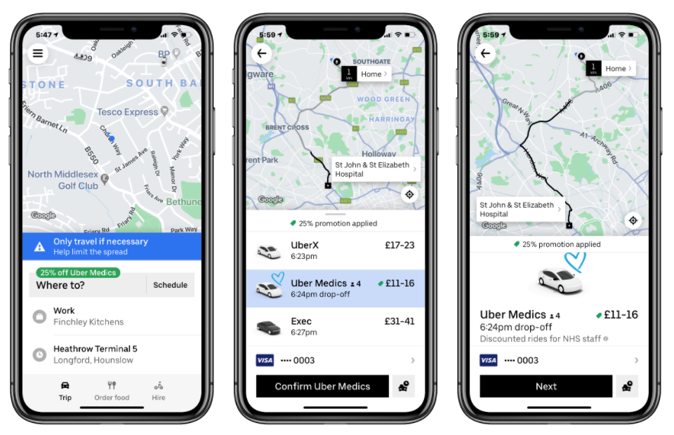

Contact
For any questions, do not hesitate to contact the support team via the HELP section in the app, or via email at business-support@uber.com

These instructions are also available on the Care Provider Alliance website.

Best wishes

Care Provider Alliance and Uber

